VS-RK3399 Specification

Content
Cover……………………………………………………1
Content………………………………………………….2
1、Specification …………………………………….. . 3
2、Product Picture……………………………………..4
3、Ports parameter ……………………………….........5
4、Notes…………………………………………..........7
5、Production Environment………………………........8

1. Products Parameters
Parameters
CPU | Rockchip RK3399 (28nm HKMG processing） 6 Core ARM® 64bit ，frequency up to 2.0GHz Big.Little architecture: Dual Cortex-A72 + Quad Cortex-A53, 64-bit CPU
GPU | Mali-T864 GPU, OpenGL ES1.1/2.0/3.0/3.1, OpenVG1.1, OpenCL, DX11;  Supports AFBC (ARM Frame Buffer Compression)
Video Decode | 4K VP9 and 4K 10bits H265/H264 video decoders, up to 60fps  1080P other video decoders (VC-1, MPEG-1/2/4, VP8)  1080P video encoders for H.264 and VP8  Video post processor: de-interlace, de-noise, enhancement for edge/detail/color
Power management | RK808 PMU Chip
Audio Format | Support MP3/AAC/WAV/WMA/Dolby True HD/DTS-HD/LPCM  /H264/VP8/MVC/Double track 4Ω/3W、8Ω/2W output
Video format | Supports RMVB,FLV,MPEG1/2/4,AVI,WMV,MOV,MP4,TS,etc
Photo format | Supports JPG/BMP/GIF/TIFF/PNG
DDR | Dual channel DDR3-1866/DDR3L-1866/LPDDR3-1866/LPDDR4
Flash | High speed eMMC 16G/32G（ optional ）  Support eMMC 5.1 with HS400, SDIO 3.0 with HS200
Display Resolution | Max up to 3840X2160 resolution ratio,and HDMI2.0
OS | Android 7.1
Hardware Futures
Ethernet | 10/100/1000Mbps Ethernet ( Realtek RTL8211E )
Wifi | WiFi module:（AP6356S）  2.4GHz/5GHzdual band WiFi Supports 802.11a/b/g/n/ac protocol 、2x2 MIMO technology  Bluetooth 4.1（supports BLE）
Output | 1 x HDMI 2.0 ( Type-A ), Supports 4K@60fps  1 x DP 1.2 (DisplayPort) , Supports 4K@60fps  1 x MIPI , Supports Dual channels 2560x1600@60fps  1 x eDP 1.3 ( 4 lanes with 10.8Gbps )
Audio | 1 x HDMI or 1 x DP ( DispalyPort ) , Audio output  1 x Headset , Audio input/output  1 x LINEOUT , Audio output  1 x SPEAKER , 3G/4GCommunicate speaker output ( 1.8W 8Ω/3.1W 4Ω )  2 x SPEAKER , Speaker output ( 1.5W 8Ω/2.5W 4Ω )  1 x SPDIF Digital audio ports，used for audio output  1 x 3G/4Gconmunicate by microphone  1 x Microphone，on-board audio input  1 x I2S , support 8 channels
USB ports | 4 x USB2.0 HOST，1 x USB3.0 HOST，1 x USB3.0 Type-C
Serial Ports | 1 x debug serial Ports（2pin 2.54mm DIP socket），used for developing and debugging
Camera | 2 x MIPI-CSI Camera port ( Max up to single 13Mpixel Or Dual 8Mpixel )  1 x DVP Camera port（Max up to 5Mpixel）
PCIe | 1 x Mini PCIe，for LTE
SIM | 1 x SIM slot，use for Mini PCIe extend LTE module
Touch screen | 1X Support I2C touch pad
LED | 1 x Power state LED (Red) ，1 x user defined LED (Blue)
Infrared | 1 x IR receiver ，Supports IR remote controller
RTC | Support RTC，on-board standby battery port
Button | 1 x Reset ，1 x Power，1 x upgrade
Power | 1 x DC12V - 3A ( DC 5.5*2.1mm )  1 x 2pin 2.54mm DIP Socket
Reserved Port | 42pin 2.54mm pin：  1 x I2S、2 x ADC、2 x I2C、1 x SPI/UART、2 x GPIO、1 x LINEOUT、1 x SPEAKER
System Upgrade | USB Upgrade 、TF Upgrade

2.Product Picture
1）Port description(only for reference,please make the object as the standard)：
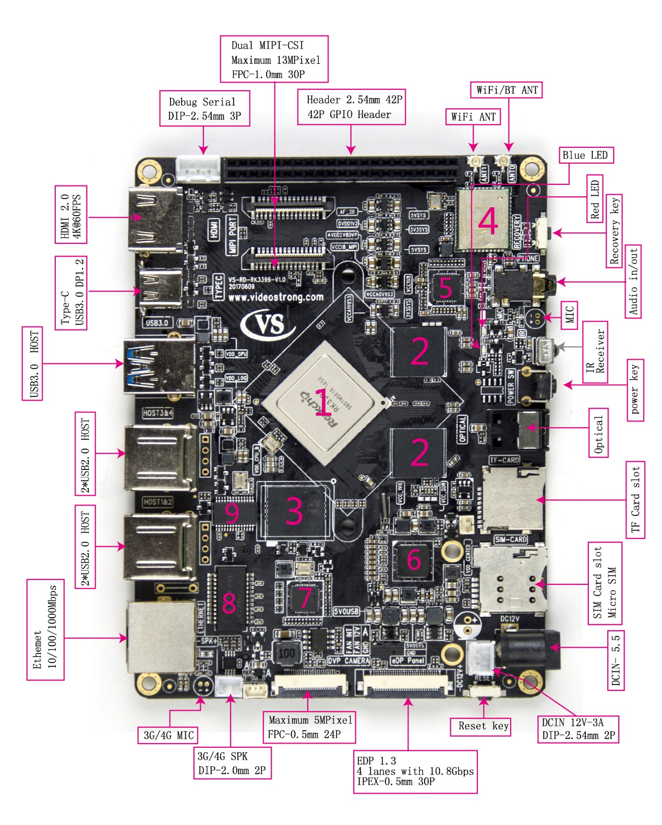
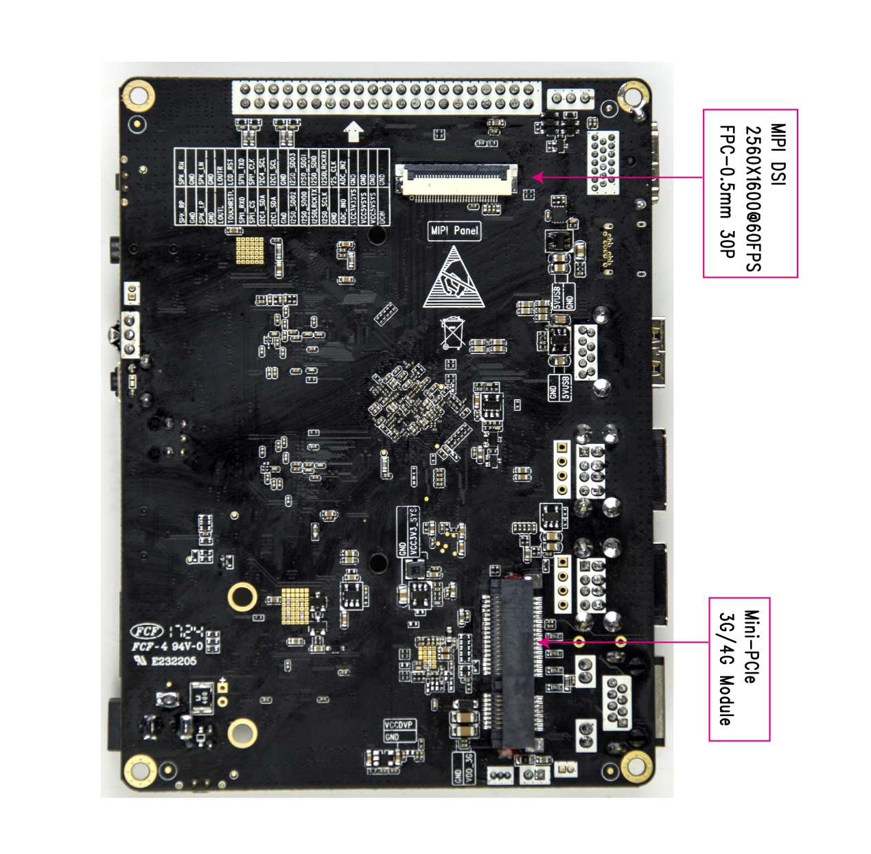

1.RK3399 Soc 2.4G LPDDR3
3.32G EMMC 4.AP6356S
5.ALC5640 Codec 6.PMU RK808
7.RTL8211E PHY 8. H5009NL
9.GL852G USB HUB
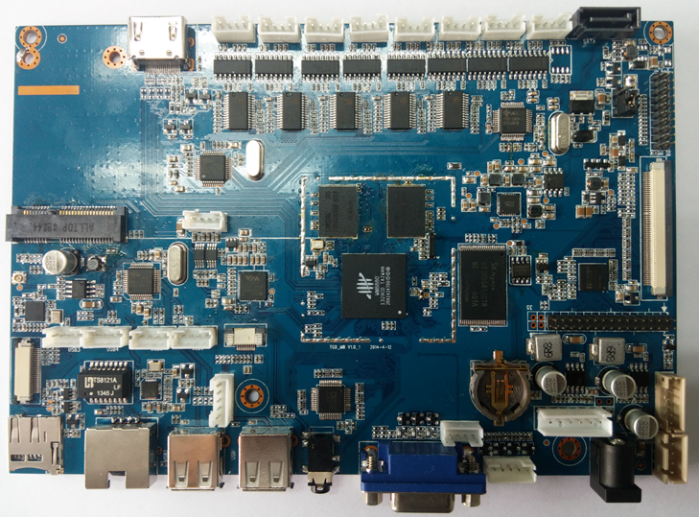
2）PCB Size：(127 * 95.5)mm
串口*8
SATA
单8 LVDS
FFC
双8LVDS
HDMI
1GDDR3
4G NAND
WM8880 CPU
Mini PCI-E 3G
音频
USB*4
摄像头
TF卡座
RJ45
USB*2
音频
VGA
遥控座
i2c
背光
2.5mm DC座
SATA 电源接口
RTC
屏电压跳线

3、Interface Specification

1）DCIN (DIP2P-2.54mm) J5 :
NO. | Name | attribute | description
1 | 12VIN | input | 12V input
2 | GND | GND | GND

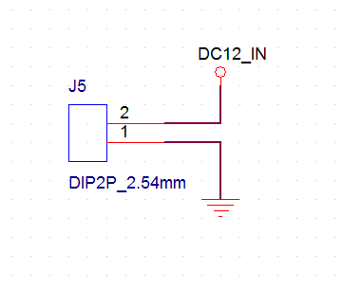
2）42P GPIO Header(DIP 21pin*2*2.5mm) J8903 :

NO. | Name | Attribute | Description
1 | +12V | power | 12V output
2 | GND | GND | GND
3 | +5V | output | 12V output
4 | GND | GND | GND
5 | +5V | power | 5V output
6 | GND | GND | GND
7 | +3.3V | power | 3.3V output
8 | GND | GND | GND
9 | ADC_IN0 | Input/output | ADC Input/output
10 | ADC_IN2 | Input/output | ADC Input/output
11 | GND | GND | GND
12 | I2S_CLK | Signal wire | Signal wire
13 | I2S0_SCLK | Signal wire | Signal wire
14 | I2S0_LRCK_RX | Signal wire | Signal wire
15 | I2S0_LRCK_TX | Signal wire | Signal wire
16 | I2S0_SDI0 | Signal wire | Signal wire
17 | I2S0_SDO0 | Signal wire | Signal wire
18 | I2S0_SDO1 | Signal wire | Signal wire
19 | I2S0_SDO2
20 | I2S0_SDO3 | Signal wire | Signal wire
21 | GND | GND | GND
22 | GND | GND | GND
23 | I2C1_SDA | Signal wire | Signal wire
24 | I2C1_SCL | Signal wire | Signal wire
25 | I2C4_SDA | Signal wire | Signal wire
26 | I2C4_SCL | Signal wire | Signal wire
27 | SPI1_CS | Signal wire | Signal wire
28 | SPI1_CLK | Signal wire | Signal wire
29 | SPI1_RXD | Signal wire | Signal wire
30 | SPI1_TXD | Signal wire | Signal wire
31 | TOUCH_RST_L | Signal wire | Signal wire
32 | LCD_RST | Signal wire | Signal wire
33 | LOUTL | output | LINEOUT-L
34 | LOUTR | output | LINEOUT-R
35 | GND | GND | GND
36 | GND | GND | GND
37 | SPK_LP | output | SPK-LP out
38 | SPK_LN | output | SPK-LN out
39 | GND | GND | GND
40 | GND | GND | GND
41 | SPK_RP | output | SPK-RP out
42 | SPK_RN | output | SPK-RN out
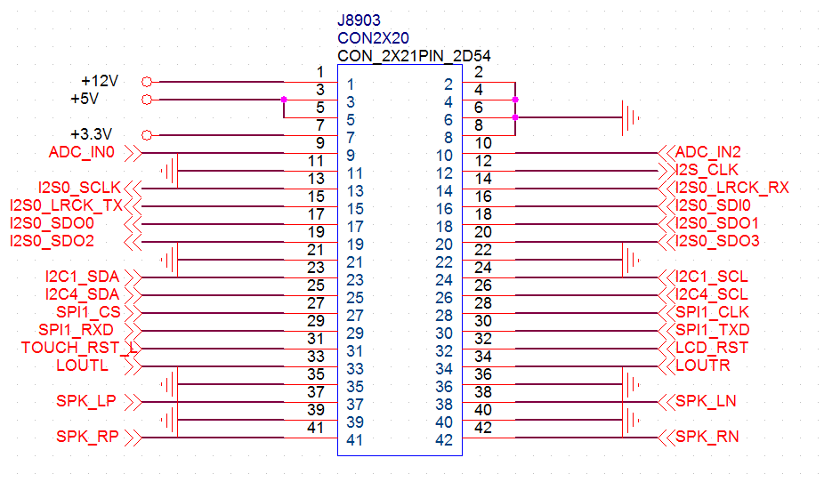

3）eDP Panel(IPEX-0.5mm 30P) J6 ：
NO. | name | Attribute | description
1 | VCC -inverter | power | Back Light inverter power input（+5V/+12V）
2 | VCC -inverter | power | Back Light inverter power input（+5V/+12V）
3 | VCC -inverter | power | Back Light inverter power input（+5V/+12V）
4 | GND | GND | GND
5 | I2C_ID1 | Signal wire | Signal wire
6 | +3.3V | power | Panel power input
7 | I2C4_SDA_TOUCH | output | TP _I2C_SDA
8 | I2C4_SCL_TOUCH | output | TP _I2C_SCL
9 | LCD_EN_H | output | Lcd enable
10 | TOUCH_INT_L | output | TP _INT
11 | BL_EN | output | Backlight enable
12 | BL_PWM1 | output | Backlight Pwm
13 | LCD_RST | output | LCD_Reset
14 | TOUCH_RST_L | output e | TP _Reset
15 | GND | GND | GND
16 | EDP_TX3P | output | Positive eDP Differential Data Input – 4thChanne
17 | EDP_TX3N | output | Negative eDP Differential Data Input – 4th Channel
18 | GND | GND | GND
19 | EDP_TX2P | output | Positive eDP Differential Data Input – 3rd Channel
20 | EDP_TX2N | output | Negative eDP Differential Data Input – 3rd Channe
21 | GND | GND | GND
22 | EDP_TX1P | output | Positive eDP Differential Data Input – 2nd Channel
23 | EDP_TX1N | output | Negative eDP Differential Data Input – 2nd Channel
24 | GND | GND | GND
25 | EDP_TX0P | output | Positive eDP Differential Data Input – 1st Channel
26 | EDP_TX0N | output | Negative eDP Differential Data Input – 1st Channel
27 | GND | GND | GND
28 | EDP_AUXP | output | DP Aux channel [Positive]
29 | EDP_AUXN | output | DP Aux channel [Negative]
30 | GND | GND | GND
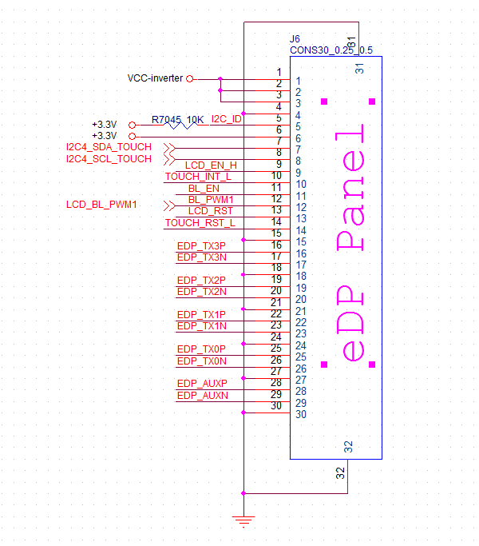
4）MIPI Panel(FPC-0.5mm 30P) J8904 ：
NO. | name | attribute | description
1 | MIPI_TX0_D0P | Output | Positive Transmission Data of Pixel 0(Odd)
2 | MIPI_TX0_D0N | Output | Negative Transmission Data of Pixel 0(Odd)
3 | GND | GND | GND
4 | MIPI_TX0_D1P | Output | Positive Transmission Data of Pixel 1(Odd)
5 | MIPI_TX0_D1N | Output | Negative Transmission Data of Pixel 1(Odd)
6 | GND | GND | GND
7 | MIPI_TX0_CLKP | Output | MIPI MDP clock output
8 | MIPI_TX0_CLKN | Output | MIPI MDN clock output
9 | GND | GND | GND
10 | MIPI_TX0_D2P | Output | Positive Transmission Data of Pixel 2(Odd)
11 | MIPI_TX0_D2N | Output | Negative Transmission Data of Pixel 2(Odd)
12 | GND | GND | GND
13 | MIPI_TX0_D3P | Output | Positive Transmission Data of Pixel 3(Odd)
14 | MIPI_TX0_D3N | Output | Negative Transmission Data of Pixel 3(Odd)
15 | GND | GND | GND
16 | LCD_EN_H | Output | Lcd enable
17 | BL_EN | Output | Backlight enable
18 | LCD_RST | Output | LCD_Reset
19 | BL_PWM0 | Output | Backlight Pwm
20 | +3.3V | Output | LCD Power
21 | +3.3V | Output | LCD Power
22 | TP_RST | Output | TP_Reset
23 | TOUCH_INT_L | Output | TP_INT
24 | I2C4_SDA_TOUCH | Output | TP _I2C_SDA
25 | I2C4_SCL_TOUCH | Output | TP _I2C_SCL
26 | +3.3V | Output | TP Power
27 | +3.3V | Output | TP Power
28 | +5V | Output | Back Light inverter power inpu
29 | +5V | Output | Back Light inverter power inpu
30 | +5V | Output | Back Light inverter power inpu
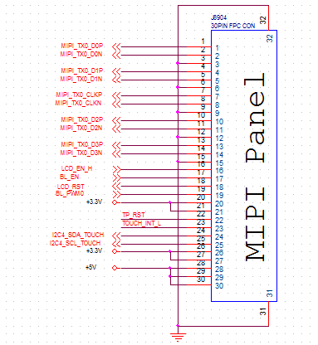

5）Mipi camera(FPC-1.0mm 30P) J4601 ：
NO. | Name | attribute | description
1 | NC
2 | VCC2V8_DVP | Output | VCC2.8V
3 | DVDD_1V2 | Output | VDD1.2V
4 | VCC18_MIPI | Output | VDD1.8V
5 | VCC5V0_SYS | NC
6 | GND | GND | GND
7 | AVDD2V8_DVP | Output | VDD2.8V
8 | GND | GND | GND
9 | I2C1_SDA_CAM | Output | I2c date line
10 | I2C1_SCL_CAM | Output | I2c clock line
11 | MIPI_RST0 | Output | Reset line
12 | DVP_PDN0_H | Output | Camera Power EN line
13 | GND | GND | GND
14 | MIPI_MCLK0 | Output | Camera clock outpu10VCCt
15 | GND | GND | GND
16 | MIPI_RX0_D3P | Output | Positive Transmission Data of Pixel 3(Odd)
17 | MIPI_RX0_D3N | Output | Negative Transmission Data of Pixel 3(Odd)
18 | GND | GND | GND
19 | MIPI_RX0_D2P | Output | Positive Transmission Data of Pixel 2(Odd)
20 | MIPI_RX0_D2N | Output | Negative Transmission Data of Pixel 2(Odd)
21 | GND | GND | GND
22 | MIPI_RX0_D1P | Output | Positive Transmission Data of Pixel 1(Odd)
23 | MIPI_RX0_D1N | Output | Negative Transmission Data of Pixel 1(Odd)
24 | GND |  | GND
25 | MIPI_RX0_CLKP | Output | Mipi camera Dp clock
26 | MIPI_RX0_CLKN | Output | MIpi camera DN clock
27 | GND | GND | GND
28 | MIPI_RX0_D0P | Output | Positive Transmission Data of Pixel 0(Odd)
29 | MIPI_RX0_D0N | Output | Negative Transmission Data of Pixel 0(Odd)
30 | GND | GND | GND

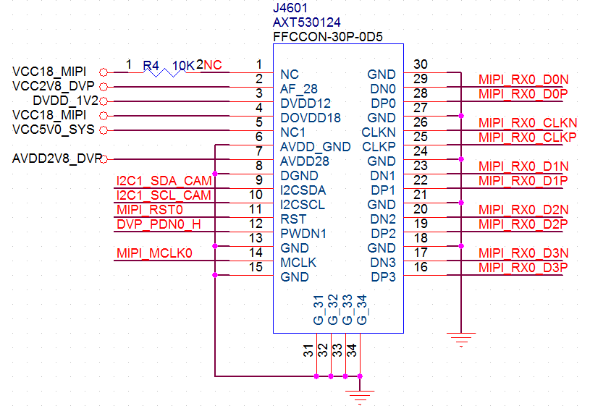
6）Mipi camera(FPC-1.0mm 30P) J4602 ：
NO. | Name | Attribute | description
1 | NC
2 | VCC2V8_DVP | Output | VCC2.8V
3 | DVDD_1V2 | Output | VDD1.2V
4 | VCC18_MIPI | Output | VDD1.8V
5 | VCC5V0_SYS | NC
6 | GND | GND | GND
7 | AVDD2V8_DVP | Output | VDD2.8V
8 | GND | GND | GND
9 | I2C1_SDA_CAM | Output | I2c date line
10 | I2C1_SCL_CAM | Output | I2c clock line
11 | MIPI_RST1 | Output | Reset line
12 | DVP_PDN1_H | Output | Camera Power EN line
13 | GND | GND | GND
14 | MIPI_MCLK1 | Output | Camera clock outpu10VCCt
15 | GND | GND | GND
16 | MIPI_TX1/RX1_D3P | Output | Positive Transmission Data of Pixel 3(Odd)
17 | MIPI_TX1/RX1_D3N | Output | Negative Transmission Data of Pixel 3(Odd)
18 | GND | GND | GND
19 | MIPI_TX1/RX1_D2P | Output | Positive Transmission Data of Pixel 1(Odd)
20 | MIPI_TX1/RX1_D2N | Output | Negative Transmission Data of Pixel 2(Odd)
21 | GND | GND | GND
22 | MIPI_TX1/RX1_D1P | Output | Positive Transmission Data of Pixel 1(Odd)
23 | MIPI_TX1/RX1_D1N | Output | Negative Transmission Data of Pixel 0(Odd)
24 | GND | GND | GND
25 | MIPI_TX1/RX1_CLKP | Output | Mipi camera Dp clock
26 | MIPI_TX1/RX1_CLKN | Output | MIpi camera DN clock
27 | GND | GND | GND
28 | MIPI_TX1/RX1_D0P | Output | Positive Transmission Data of Pixel 0(Odd)
29 | MIPI_TX1/RX1_D0N | Output | Negative Transmission Data of Pixel 0(Odd)
30 | GND | GND | GND

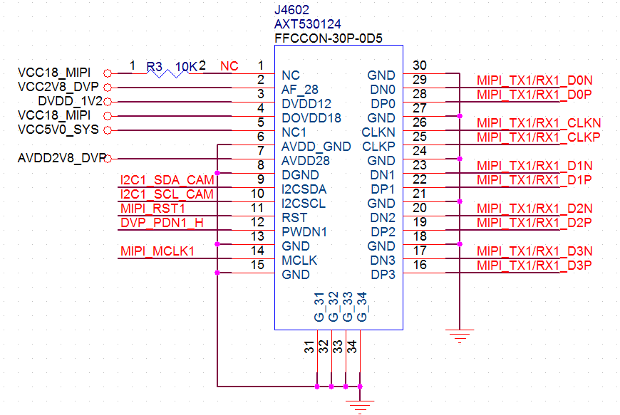

7）DVP(FPC-0.5mm 24P) J4501 ：
NO. | Name | Attribute | Description
1 | DVP_PDN1_H | output | Camera PDNW1 line
2 | GND | GND | GND
3 | I2C1_SDA_CAM | output | I2c date line
4 | VCC2V8_DVP - | output | VCC2.8V
5 | I2C1_SCL_CAM | output | I2c clock line
6 | CIF_RST | output | Reset line
7 | CIF_VSYNC | output | Vsync line
8 | DVP_PDN0_H | output | Camera PDNW0 line
9 | CIF_HREF | output | Hsync line
10 | DVP_DVDD | output | VDD1.8V
11 | VCC1V8_DVP | output | VCC1.8V
12 | CIF_D7 | output | Camera parallel port signal D7
13 | CIF_CLKOUT | output | Camera CLKIN
14 | CIF_D6 | output | Camera parallel port signal D6
15 | GND | GND | GND
16 | CIF_D5 | output | Camera parallel port signal D5
17 | CIF_CLKIN | input | Camera CLKOUT
18 | CIF_D4 | output | Camera parallel port signal D4
19 | CIF_D0 | output | Camera parallel port signal D0
20 | CIF_D3 | output | Camera parallel port signal D3
21 | CIF_D1 | output | Camera parallel port signal D1
22 | CIF_D2 | output | Camera parallel port signal D2
23 | GND | GND | GND
24 | NC

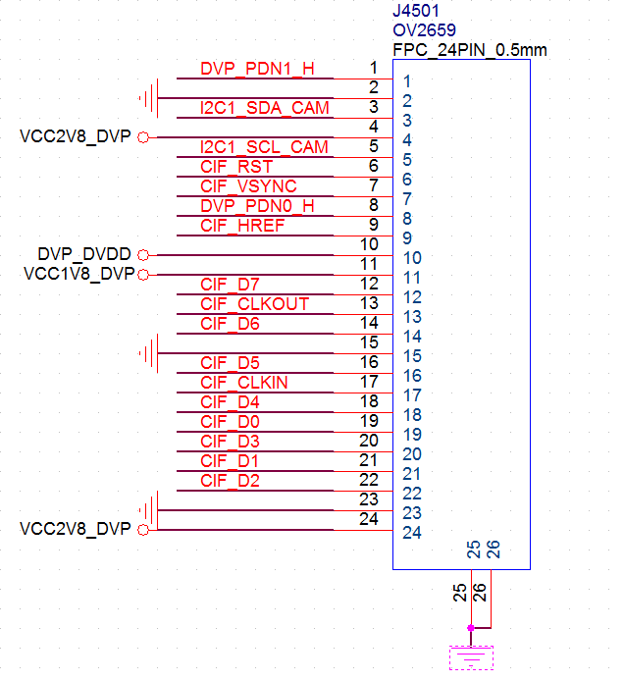

8）Debug Serial(DIP-2.54mm 3P) 2J2 ：
NO. | Name | Attribute | Description
1 | UART2_RXD | input | RX
2 | UART2_TXD | output | TX
3 | GND | GND | GND
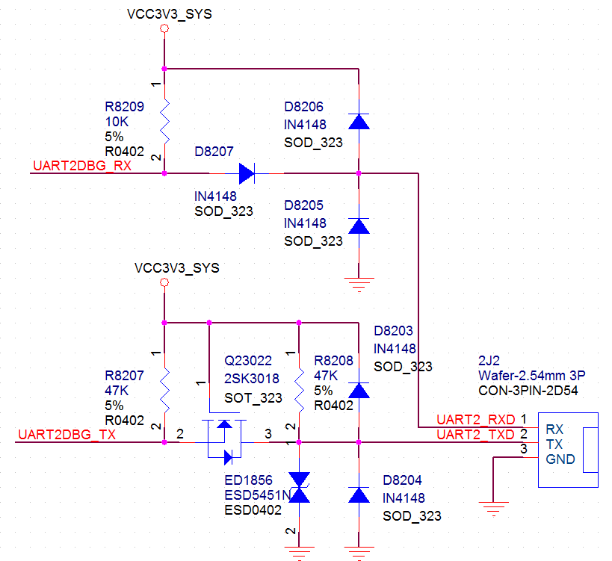
9）3G/4G SPK (DIP-2.0mm 2P) J7 ：
NO. | Name | Attribute | Description
1 | SPK_N | output | SPK_N output
2 | SPK_P | output | SPK_P output
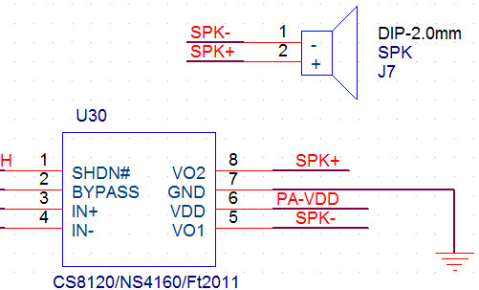
4．Operation Notes：
A, Relative Temperature ≦80%；
B, Storage temperature：-10℃—60℃；
C, Operating temperature：0℃—40℃；
D, Make sure of the electrostatic prevention during the transportation and complete machine assembling
F, No hard pressing, twisting or dropping
G, No power before connecting the panel correctly.
H, Don’t put together with the ones which are electric conduction during working.
I, Don’t repair or dismantle if not professional ones.
.Production Environment
